XML Parser

🧠 What is an XML Parser?
# Source: AI Source: Provided by: [Data Path: Persons Table -> ID Column: 1, Name_En Column: Motasem Essam] -> From: [Chatgpt (GPT‑5 Mini)] on [12/9/2025]
An XML parser is a tool or program that reads XML documents, checks their structure, and converts them into a format that software (like a web browser or application) can understand and work with — such as a tree structure or objects.

🔹 Key Purpose
# Source: AI Source: Provided by: [Data Path: Persons Table -> ID Column: 1, Name_En Column: Motasem Essam] -> From: [Chatgpt (GPT‑5 Mini)] on [12/9/2025]
An XML parser takes raw XML text and transforms it into a machine-usable format, like a DOM tree or data stream.

📄 Example: Raw XML
# Source: AI Source: Provided by: [Data Path: Persons Table -> ID Column: 1, Name_En Column: Motasem Essam] -> From: [Chatgpt (GPT‑5 Mini)] on [12/9/2025]
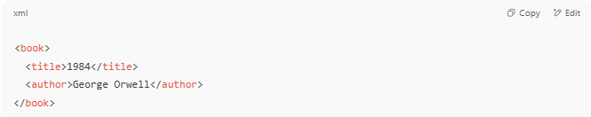
<book>
<title>1984</title>
<author>George Orwell</author>
</book>

An XML parser will:
- Read the XML
- Validate its structure (e.g. is it well-formed?)
- Turn it into an internal structure like:

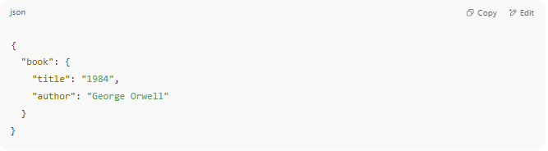
{
"book": {
"title": "1984",
"author": "George Orwell"
}
}

Or a DOM tree in memory.

🧩 Why XML Parsers Matter
# Source: AI Source: Provided by: [Data Path: Persons Table -> ID Column: 1, Name_En Column: Motasem Essam] -> From: [Chatgpt (GPT‑5 Mini)] on [12/9/2025]
- ✅ Allow programs to read and extract data from XML
- ✅ Can validate XML against a schema (XSD)
- ✅ Enable data exchange between systems
- ✅ Power systems like SOAP APIs, RSS feeds, Android apps, and Office formats

🔧 Types of XML Parsers
# Source: AI Source: Provided by: [Data Path: Persons Table -> ID Column: 1, Name_En Column: Motasem Essam] -> From: [Chatgpt (GPT‑5 Mini)] on [12/9/2025]
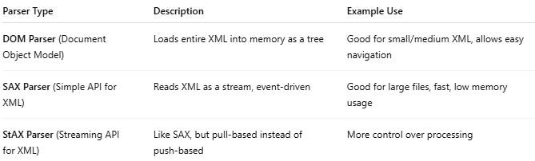
Parser Type | Description | Example Use
DOM Parser (Document Object Model) | Loads entire XML into memory as a tree | Good for small/medium XML, allows easy navigation
SAX Parser (Simple API for XML) | Reads XML as a stream, event-driven | Good for large files, fast, low memory usage
StAX Parser (Streaming API for XML) | Like SAX, but pull-based instead of push-based | More control over processing

🔸 Popular XML Parsers by Language
# Source: AI Source: Provided by: [Data Path: Persons Table -> ID Column: 1, Name_En Column: Motasem Essam] -> From: [Chatgpt (GPT‑5 Mini)] on [12/9/2025]
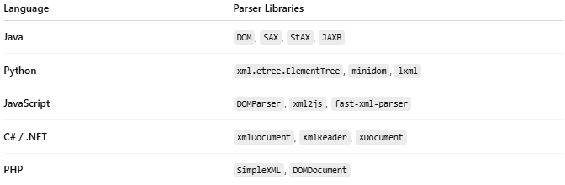
Language | Parser Libraries
Java | DOM, SAX, StAX, JAXB
Python | xml.etree.ElementTree, minidom, lxml
JavaScript | DOMParser, xml2js, fast-xml-parser
C# / .NET | XmlDocument, XmlReader, XDocument
PHP | SimpleXML, DOMDocument

✅ Well-Formed XML Check
# Source: AI Source: Provided by: [Data Path: Persons Table -> ID Column: 1, Name_En Column: Motasem Essam] -> From: [Chatgpt (GPT‑5 Mini)] on [12/9/2025]
An XML parser checks if your XML is well-formed, meaning:
- Has a single root element
- Properly nested tags
- Quotes around attribute values
- No unescaped characters like &, <, >

🚫 Example of Invalid XML:
# Source: AI Source: Provided by: [Data Path: Persons Table -> ID Column: 1, Name_En Column: Motasem Essam] -> From: [Chatgpt (GPT‑5 Mini)] on [12/9/2025]
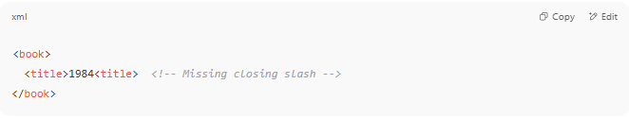
<book>
<title>1984<title> <!-- Missing closing slash -->
</book>

An XML parser would raise an error here.

🧠 Summary
# Source: AI Source: Provided by: [Data Path: Persons Table -> ID Column: 1, Name_En Column: Motasem Essam] -> From: [Chatgpt (GPT‑5 Mini)] on [12/9/2025]
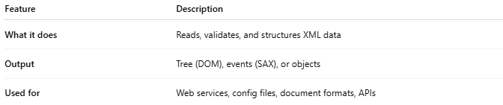

Feature | Description
What it does | Reads, validates, and structures XML data
Output | Tree (DOM), events (SAX), or objects
Used for | Web services, config files, document formats, APIs

Would you like a live code demo of XML parsing in Python, JavaScript, or another language?

